Daphne Taylor FCA PCC ORSCC
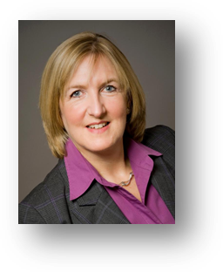
Daphne specialises in senior team and board coaching, and has a track record of success working with teams and individuals in the UK and internationally over the past 13 years.
Acting as an agent for powerful and sustainable change, her work provides a positive impact on bottom line results, organisational culture and personal fulfilment. Her natural people skills combined with sharp business acumen create an environment for courageous conversations that allow individuals and teams to develop and flourish in both increased performance and greater positivity

Having qualified as a Chartered Accountant with Deloitte, she spent over 16 years in Financial and senior management roles, before becoming a professional coach. She has extensive experience as a board member including as Company Secretary of a public company and Group Treasurer for an International Luxury Goods Brand.
In addition to coaching and team development, Daphne is also a faculty member of CRR Global and supervises team coaches in training. Recently Daphne is one of the first coaches in the UK to have been listed on the Board and Team Coaching Register of the NHS Leadership Academy
Daphne specialises in the following areas:
- developing leadership
- personal effectiveness
- facilitating culture change
- behavioural changes
- resolving conflict
- developing high performing teams
- increasing positivity and trust in teams

Professional Qualifications:
Professional Certified Coach, Coaches Training Institute (CPCC)
Graduate of CTI’s Co-Active Leadership Programme
Certified Organisation & Relationship Systems Coach and Supervisor (ORSCC)
Professionally Certified Coach with International Coach Federation (PCC)
Master Practitioner NLP
Accredited Practitioner TMSDI psychometric profiling tools
Authorised Facilitator of Team Diagnostic™ Assessment
Chartered accountant (FCA)
BSC (Hons) Geography

Career Summary:
Diamond Edge Director 2003 to date
Daphne Taylor Coaching and Mentoring consultancy 1998-2003
LVMH bv Group Treasurer 1995-1997

Early Career:
Deloitte; London Scottish Finance plc, N Brown Group plc

.

